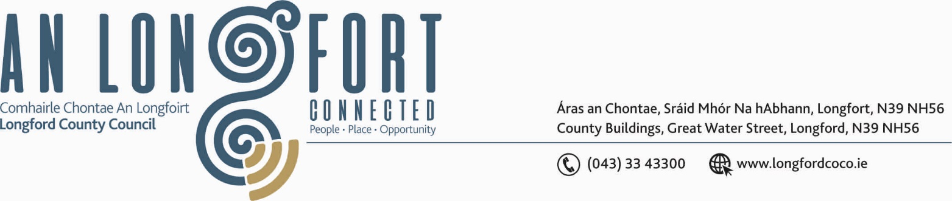

GRANARD MUNICIPAL DISTRICT

Corporate Affairs,
Aras an Chontae,
Please note meeting commencing
at 4.00 p.m. this month LONGFOIRT.

17th July 2019.

To: Each Member of Granard Municipal District.

Dear Member,

You are requested to attend Meeting of Granard Municipal District to be held in
Granard Community Library on Tuesday, 23rd July 2019 at 4.00 p.m. to transact business, as set out on the Agenda hereunder.

Yours sincerely,
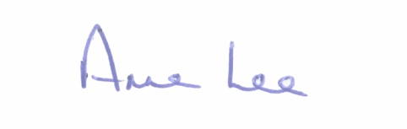

_______________
Anne Lee,
Meetings Administrator.

AGENDA

Prayer before meeting.

1. Confirmation of the Minutes of the following Meetings of Granard Municipal District - copies enclosed
(a) Committee Meeting held on the 22nd March 2019.
(b) March Municipal District Meeting held on the 22nd March 2019.
(c) Annual Meeting held on the 17th June 2019.

2. Matters arising from Minutes.

3. Declaration of Interest by Members.

4. Attendance by Fergus Kennedy, Arts Officer.

5. Area Engineer’s Progress Report.

6. Approval to attendance of Granard Municipal District Member at Twinning Event in Essert, France on the 25th July 2019.

7. Notices of Motions, submitted by Councillors, as listed hereunder -

Councillor Micheál Carrigy.

“I call on Longford County Council to carry out upgrade works on Market Street, Granard to include repair/replacement of the footpaths and the railings.”

Councillor P.J. Reilly.

“I wish to put a motion forward to the meeting for the Council to apply for a Low Cost Safety Scheme so as to stagger the junction at Purth Cross. This is one of the most dangerous junctions in the County.”

Councillor Turlough McGovern.

“That a Yellow Box Junction and relevant signage be provided on Church View Road, Granard – this request is of high importance as there could be a health and safety risk at this location.”

“The footpath as you turn off N55 to Ballymorris Road is very uneven and needs to be replaced.”

“That the buckled railings and the condition of the path at Market Street be addressed, as this issue is ongoing since 2017.”

Councillor Garry Murtagh.

“That Road safety measures be undertaken at:
- Molly Cross
- Dolans Hill
- Smear Road/Shrine.”

“Village Enchantment measures for Aughnacliffe -
- Complete the Footpaths on the approach roads & Village Environs
- Upgrade & extension of village lighting
- Review of traffic calming measures in the village.”

